**Bogert School Code of Conduct Philosophical Statement**

The goal of the Bogert School Student Code of Conduct is to establish standards of conduct that will: promote a safe and welcoming school environment, allow students to do their best learning, and foster positive relationships between all members of the school community. The social, emotional, and academic success of all students is paramount and the Code of Conduct will set forth rights and responsibilities that allow all students to receive a high quality and well-rounded education in a nurturing environment.

The Upper Saddle River Schools pride themselves on valuing diversity and promoting an anti-hate environment. This includes an intolerance for racial slurs or any hurtful language motivated by race, religion or ethnicity. Any incidents of bullying, intimidation, or harassment should be reported to the Bogert School Anti-Bullying Specialist. These guidelines will be used when dealing with conflicts that may or may not rise to the level of [HIB](https://www.straussesmay.com/seportal/Public/DistrictPolicy.aspx?policyid=5512&id=a6833e856c3d4091ad729edf7b02b969).

**Misbehaviors and Consequences**

We believe that elementary school is a time to grow and learn from mistakes. We emphasize learning, and consequences for misbehavior are guided by our developmentally appropriate philosophy. Remedial measures shall be designed to correct problematic misbehavior, prevent additional occurrences and provide support for students. Repeated violations of the Student Code of Conduct may result in exclusion from field trips and other special school events. We respect the privacy of all students and will not share the consequences of a student with anyone other than their parent/guardian.



*Page 1 of 3*

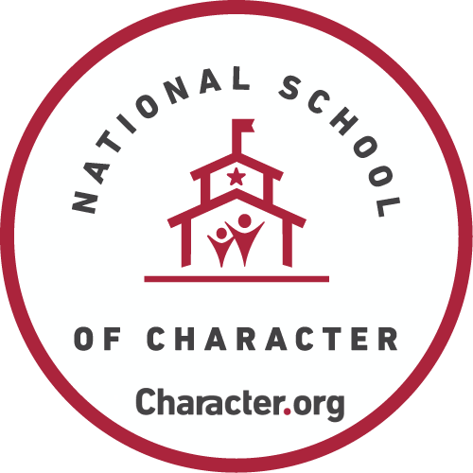Bogert Elementary School

**STUDENT CODE OF CONDUCT**

**As a student at Bogert Elementary School:**

**I have the right to be respected; therefore, I have the responsibility to be respectful to others.**

* I will accept and include others.
* I will choose words that won’t hurt others and will not use hateful language.
* I will listen to the ideas and opinions of others.
* I will not be a bully and will not allow others to be bullied.

**I have the right to feel safe; therefore, I have the responsibility to be safe and to keep others safe.**

* I will follow school rules (classroom, lunchroom, playground, bus).
* I will respect others’ personal space and keep my hands and feet to myself.
* I will walk in the hallways at all times.
* I will help make Bogert a bully-free school.

**I have the right to learn; therefore, I have the responsibility to work peacefully.**

* I will try my best and allow others to try their best.
* I will be a good partner by working cooperatively.
* I will work quietly when working independently.

# **I have the right to be successful in school; therefore, I have the responsibility to do my personal best.**

* I will come to school on time and prepared for learning.
* I will complete my assignments on time.
* I will act responsibly and learn from my mistakes.
* I will accept the direction of all Upper Saddle River teachers and other adults.

**I have the right to be a citizen of the school community; therefore, I have the responsibility to treat people, materials, the building, and grounds with respect.**

* I will take care of school materials and property.
* I will help keep the school clean and neat by properly disposing of litter and recycling.
* I will take pride in my personal contributions and school accomplishments.
* I will acknowledge my peers’ contributions and personal successes.
* I will behave kindly and politely.

I hereby indicate that I have read, discussed, and will uphold the Bogert Elementary School’s *Student Code of Conduct.*

___________________________ ____________________________

Student’s Signature & Date Parent’s Signature & Date

*Page 2 of 3*

|  |  |  |  |
| --- | --- | --- | --- |
| **Misbehavior** | **1st Level Consequence** | **2nd Level Consequence** | **3rd+ Level Consequence** |
| *Dishonesty, Lying, Cheating*  *Disrespect to Students or Staff*  *Disruption to School Environment*  *Inappropriate Language and/or Gestures*  *Misconduct during Safety Drills*  *Misuse of Electronic Devices*  *Misuse of the Internet*  *Not Being Where You’re Supposed to Be*  *Selling Items or  Services at School*  *Teasing Others*  *Wearing Hats/Hoodies* | Teacher addresses the misbehavior which can include an opportunity to apologize, a do-over and/or collaborative problem-solving discussion.  Parent is contacted by the teacher. | Teacher addresses the misbehavior which can include an opportunity to apologize, a do-over and/or collaborative problem-solving discussion.  Parent is contacted by the teacher.  Teacher meets with the student. A reflection form is completed.  Detention(s) is assigned. | Teacher contacts administrator and appropriate support staff regarding the misbehavior.  Student meets with an administrator.  Parent is contacted by an administrator.  Detention(s) is assigned.  I&RS referral may be considered.  Parent meeting with school staff may be considered. |
| **Misbehavior** | **1st Level Consequence** | **2nd Level Consequence** | **3rd+ Level Consequence** |
| *Fighting*  *Insubordination*  *Misuse of School Property and/or School Equipment*  *Physical Act*  [*Possession of a*](https://www.straussesmay.com/seportal/Public/DistrictPolicy.aspx?policyid=8467&id=a6833e856c3d4091ad729edf7b02b969)  [*Dangerous Object*](https://www.straussesmay.com/seportal/Public/DistrictPolicy.aspx?policyid=8467&id=a6833e856c3d4091ad729edf7b02b969)  *Stealing*  *Threatening Remarks*  *Vandalism* | Teacher contacts administrator and appropriate support staff regarding the misbehavior.  Administrator meets with the student.  Parent is contacted by administrator.  Parent meeting with school staff may be considered.  I&RS referral may be considered.  Detention(s) is assigned and suspension(s) may be considered. | Student meets with administrator and completes a reflection form.  Parent is contacted by an administrator.  Parent meeting with administrator and teacher/support staff may be conducted.  I&RS referral may be considered.  Detention(s) and/or suspension(s) is assigned. | Student meets with administrator and completes a reflection form.  Parent is contacted by an administrator.  Parent meeting with administrator and teacher/support staff is conducted.  I&RS referral is made.  Detention(s) and/or suspension(s) is assigned. |

*While we believe the consequences in the above chart will generally guide our school’s response to misbehavior, there are times when administrative discretion may be used; consequences may vary and may not be all inclusive of those listed on the chart.*